NAME: Bhoomi Batra
SECTION: A2_B4
ROLL NO: 60

Task 1:
Scenario:
A university digital library system stores frequently accessed books using a binary search mechanism. The library admin wants to minimize the average search time for book lookups by arranging the book IDs optimally in a binary search tree.
Each book ID has a probability of being searched successfully and an associated probability for unsuccessful searches (when a book ID does not exist between two keys).
Your task is to determine the minimum expected cost of searching using an
Optimal Binary Search Tree (OBST).

OUTPUT:
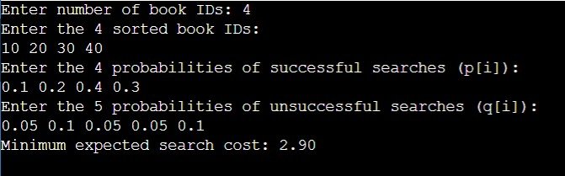

Task 2:

GREEKSFORGREEKS:
